Test # 151
Instrument Name Consistometer
Instrument Type Consistometer
Test Start 30/01/01 09:36
Test Stop 7:30:32
Well ID # KHVALYNSKAYA #3
Customer LUKOIL
Cement Class G
Additives 0.41%TR-1+1.25%SMS+1.25%TC-101+Defoamer
Cement Mfr DYKERHOFF
BHCT 45
BHST 60
Density 1450
Fluid Loss
Job Type 340MM CSG
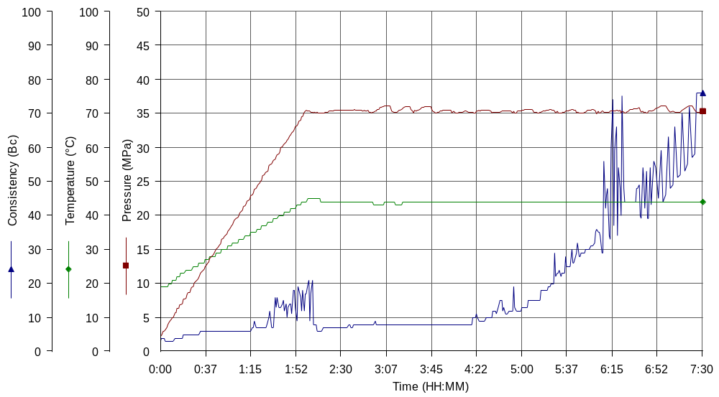
Comments MPa: 35(120min), T:45 (120min), Astrakhan technical water

